Reactions to ‘Belmont Hassocks’

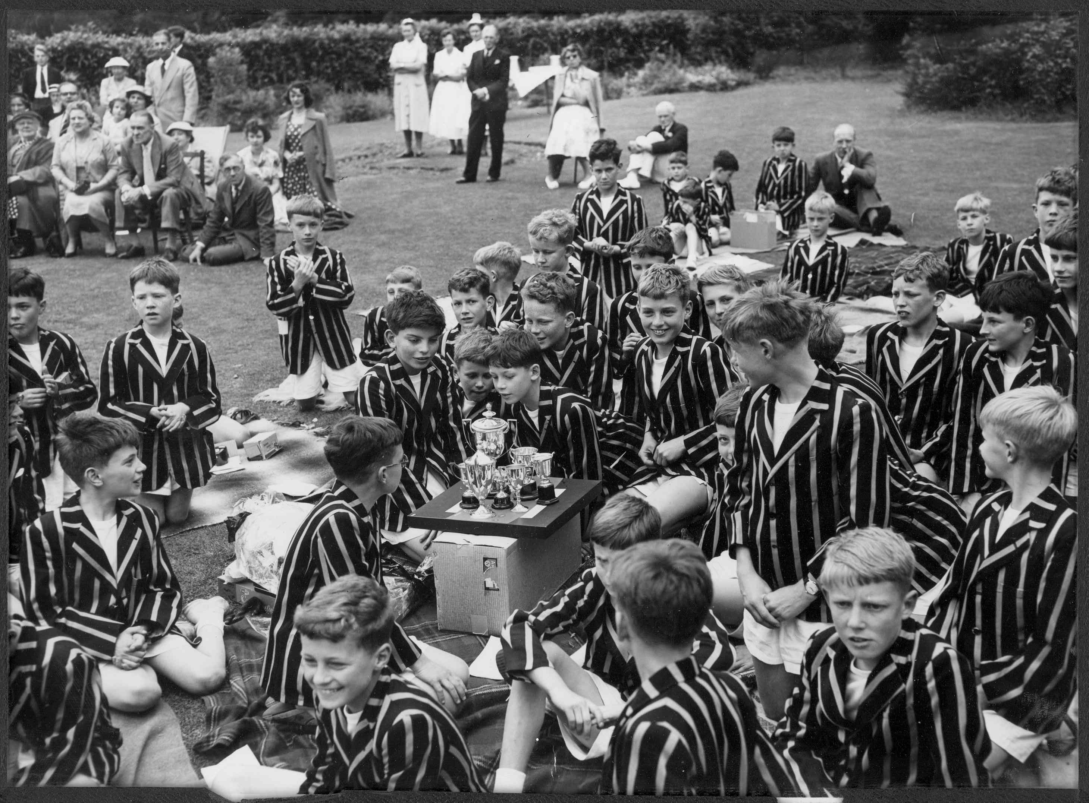
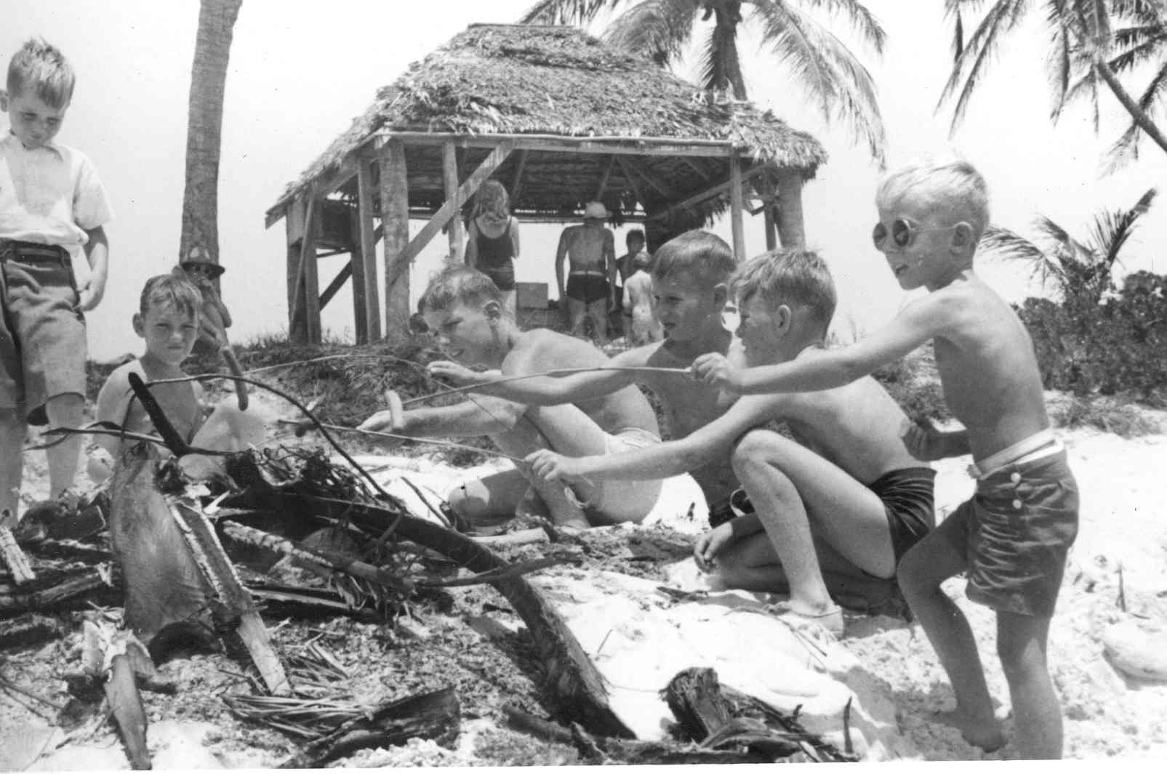
“highly
entertaining”
Got it and read it. You did a terrific job! I had been feeling guilty that I hadn't sent you any memories of my own and was relieved to find that I wouldn't have added anything significant. I had never focused on Burr's personality quirks before and hadn't a clue about Barlow's. It's an amazing story.
Tim Colton 1947-53

I received your book this morning and spent most of the afternoon reading it. I thought it was absolutely wonderful – fascinating – so cleverly written. You haven’t pulled any punches where you might have been tempted to. It’s a marvellous job. It brought many memories back to me: like running a sixer and the archery – it all came rolling back. How Barlow sacked the head gardener for putting the Union Jack upside down on the flagpole… I do thank you for doing it so brilliantly. I will enjoy re-reading it in the years to come. Congratulations on a fantastic achievement and for making it available to me.
Michael Kefford, Master 1958
I am so pleased to have been able to contribute some details to your book. I congratulate you on an altogether admirable sequence of writing and selection. It’s not only a fascinating record of a particular school (and the extraordinary Max Burr) but an intriguing piece of social history, describing detailed events in relation to the wider horizon of the period… The book is also highly entertaining and a good read from start to finish…You’ve written a splendid book, Dale, and it deserves to go on record as much more than a school history.
Alan Caiger-Smith 1938-43
I have just finished Belmont Hassocks in two sittings and I do congratulate you on it. It cannot have been an easy book to compile, let alone write, and you have done it very well indeed. There would have been no point in suppressing the darker issues around both Max Burr and Barlow, but you have handled Burr with considerable delicacy and masterly balance. Barlow must have been an impossible task and the points are made without going overboard…
Thank you again for a fascinating book. I only wish my memory had been as good as some other Old Boys – but it came flooding back. Robert Horton 1947-51
“…you have handled Burr with considerable delicacy and masterly balance.”
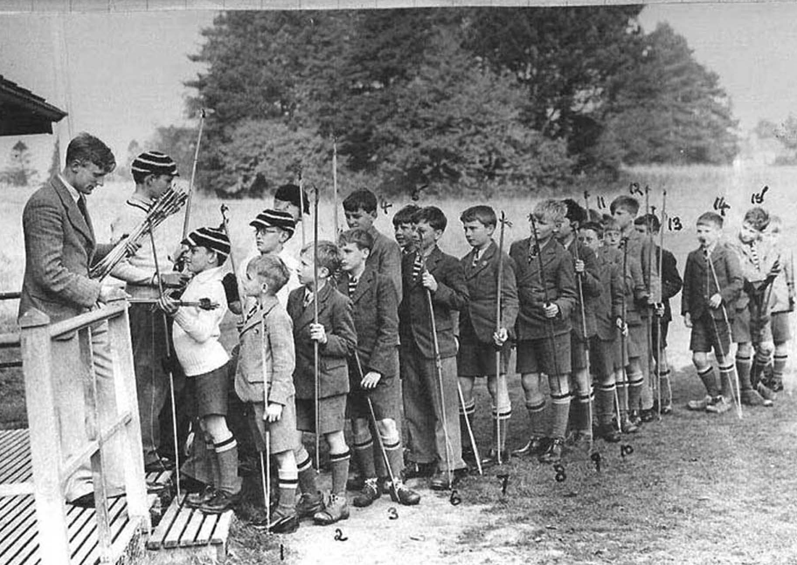
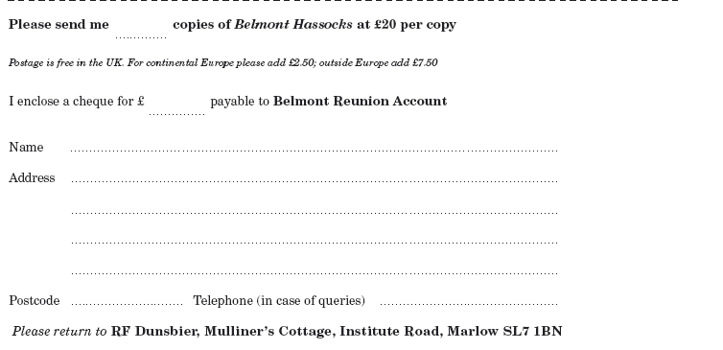
Your study of Max Burr was excellent and you were spot on. I was unable to keep up with events as I should have liked, so I was unaware of the horrors that followed… Great prep school headmasters are a unique breed – I think Max was amongst them. I loved your book. Very many thanks.
John Robertshaw 1939-42
Thank you and many congratulations on the truly superb book. I think you have managed to integrate the diverse aspects of the Belmont story with great expertise. A tour de force indeed. And what a strange tale it turned out to be, of which I suspect many like ourselves, in innocence, knew little….
John Sheppard-Fidler 1948-52
Order your copy now while stocks last…
“It is an unbelievable story and the cataclysmic ending is extraordinary.”
Just got back to find your wonderful book. Congratulations. It is a great read and suitably frank where necessary. Well done. I hope it sells out fast - it certainly deserves to.
Douglas Butler 1953-60
I just wanted to say to you that I thought the book was extremely well done. It is an unbelievable story and the cataclysmic ending is extraordinary. As you know I was not a great supporter of Burr but I was most intrigued by the story which I think you have told extremely well. It would make a very good film.
John Fontannaz 1935-39
The book is just wonderful and I want to congratulate you on a truly splendid effort. The content, the style, the presentation, the binding, are all absolutely first rate. Thank you so much for all your hard work. Please don’t kid yourself that you are no author!
Alan King 1951-56
I have just finished reading your book on Belmont and felt I must write to congratulate you on a fascinating story, so well told.
Greville Watts 1945-48

